LEARNING MANAGEMENT SOFTWARE

Team MAET

**Team Members:** Emmanuel Ogunkoya, Jonathan Thomas, Savorn Sam, Christopher Kania, Aaron Raoofi

CS 3321: Introduction to Software Engineering

Department of Computer Science and Engineering Technology

University of Houston – Downtown

Spring 2019

Table of Contents

CHAPTER 1: Overview 1

**SECTION 1.1: PROJECT SUMMARY** 1

SECTION 1.1.1: PURPOSE, SCOPE, AND OBJECTIVES 1

Section 1.1.1a: Purpose 1

Section 1.1.1b: Scope 1

SECTION 1.1.1C: Objectives 1

SECTION 1.1.2: ASSUMPTION AND CONSTRAINTS 2

Section 1.1.3: Project deliverables 2

Section 1.1.4: Schedule and Budget Summary 2

Section: 1.2: Eveolution of the Project management Plan 2

CHAPTER 2: REFERENCE MATERIALS 3

BIBLIOGRAPHY 3

Chapter 3: defnition and acronyms 4

Section 4.1: External Interfaces 5

Section 4.2: Internal Structure 5

Section 4.3: Roles and Responsibilities 5

chapter 5: Managerial process Plans 6

Section 5.1: Start-Up Plan 6

Section 5.1.1: Estimation Plan 6

Section 5.1.2: Staffing Plan 6

SEction 5.1.3: Resource Acquisisiton Plan 6

Section 5.1.4: Project Staff Training Plan 6

Section 5.2 Work Plan 6

Section 5.2.1: Work Activities 6

Section 5.2.2: work activities 6

Section 5.2.3: Budget Control Plan 6

Section 5.2.4: Quality Control Plan 6

SEction 5.3 Control Plan 6

Section 5.3.1: Requirements Control Plan 6

Section 5.3.2: Schedule Control Plan 7

Section 5.3.3: Budget Control Plan 7

Section 5.3.4: Quality Control Plan 7

Section 5.3.5: Reporting plan 7

Section 5.3.6: Metrics Collection Plan 7

Section 5.4: Risk management plan 7

Section 5.5 project Close-Out Plan 7

chapter 6: technical process plan 8

Section 6.1: Process model 8

Section 6.2: Methods, Tools & Techniques 8

Section 6.3: Infrastructure Plan 8

Section 6.4: Product Acceptance Plan 8

7: supporting process plan 9

Section 7.1: Configuration management Plan 9

Section 7.2: Testing Plan 9

Section 7.3: Documentation Plan 9

Section 7.4: Quality Assurance Plan 9

Section 7.5: Reviews and Audits Plan 9

Section 7.6: Problem Resolution Plan 9

Section 7.7: Subcontractor management Plan 9

Section 7.8: Process Improvement PlaN 9

8: additional Plan 10

Appendix 11

appendix A: Major User Views 12

appendix B: Entities 13

appendix C: Use Cases 14

appendix D: Meeting Minutes 15

appendix E: Diagrams 17

UML Diagram 17

Class Diagram & E/R Diagram 17

Appendix F: CRC Cards 18

appendix G: Login Page 19

Login page screenshot 19

Login Page Code 19

appendix H: Main Window Code 22

Version 1.0 Code 22

appendix I: Student Page 23

appendix J: Administrator Page 25

appendix K: Courses Page 26

appendix L: Courses Page 27

# CHAPTER 1: Overview

**SECTION 1.1: PROJECT SUMMARY**

As students, we are taught the theoretical and conceptual ideas and tools that we may apply in private and public sectors after graduation. We are given the opportunity to apply class room learning to a hand-on project. We (Emmanuel Ogunkoya, Jonathan Thomas, Savorn Sam, Christopher Kania and Aaron Raoofi) will take concepts taught in class, along with our cumulative working knowledge in various programming languages, as real-world experiences and apply them in creating a functioning “Learning Management System” which will display various student information as it pertains to a university institute.

## SECTION 1.1.1: PURPOSE, SCOPE, AND OBJECTIVES

### Section 1.1.1a: Purpose

The Learning Management System will provide information about a student(s) academic information, such as, student’s name, student’s ID, registered courses in the current semester, each exam’s scores in one course, GPA calculation in the current semester.

### Section 1.1.1b: Scope

The LMS is a brief example of the overall lengthier project. For now, the information provides will be for demonstration purposes. Information provided in the database (course name, id, student name, student ID or any other information) will not be for any real person(s) located at the University of Houston – Downtown or any known person.

### SECTION 1.1.1C: Objectives

* Team will analyze the requirements of the semester project.
* Review, analyze and develop life cycle model
* Review, analyze and develop team model
* Assign team member responsibilities
* develop and apply UML method
* create UML diagram
* create and maintain data records
* create Graphical User Interface (GUI)
* The program will have to access modes (student view and administrator view)
* Software will have a login page with stored login name and password.
* Software program will calculate GPA based on provided exam scores and/or quiz scores.
* The software program will store basic information (student name, student ID, registered courses, exam scores)
* The Program will display basic information, listed above, as well as GPA

## SECTION 1.1.2: ASSUMPTION AND CONSTRAINTS

Due to the time frame of this project, student knowledge, the Learning Management System will not be completely functional, rather, it will have partial functionality. The information used within the system (student information, administrator information as well as class name and course ID) are completely fictional.

## Section 1.1.3: Project deliverables

The following items will be submitted:

* Final Project Report
  + The report will include information such as the number of members in our team, team member’s names, type of team model, UML diagrams, SPMP
* Source Code
* Data storage files, and
* any other documentation required per the project assignment

## Section 1.1.4: Schedule and Budget Summary

The final project due date is April 24, 2019 during usual class time. Budget is not applicable to this project.

## Section: 1.2: Eveolution of the Project management Plan

During the course of this project should any changes, re-evaluation, or revision to this SPMP will be done under group review. Changes shall be done by any team members.

# CHAPTER 2: REFERENCE MATERIALS

# **BIBLIOGRAPHY**

*GitHub*. (2019). Retrieved from GitHub: https://github.com/

Schach, S. R. (2007). *Object-Oriented and Classical Software Engineering, 8th Edition.* New York: The McGraw-Hill Companies, Inc.

# Chapter 3: defnition and acronyms

**DTA**: Democratic Team Approach

**GUI**: Graphical User Interface

**LMS**: Learning Management System

**SPMP**: Software Project Management Plan

**UML**: Unified Modeling Language

chapter 4: project organization

## Section 4.1: External Interfaces

As the team is small, any interactions will be conducted either in group meetings between the team and the University of Houston- Downtown or with the team lead.

## Section 4.2: Internal Structure

Currently, our team will be using a combination Democratic Team Approach (DTA) as well as the Classical Chief Programmer Team Approach. Each member has had specific knowledge and skills involving different aspects of the project. Aaron Roofi has taken a defacto leadership role, due to his extensive knowledge and leadership skills. As this is an early stage, each member has voluntarily expressed his or her interest and strengths as well as volunteered for various aspects in this project.

## Section 4.3: Roles and Responsibilities

* Kania, Christopher: Lead Programmer for Login Page, Administration Page, Student Page, Graphical User Interface designer, Programmer and Artifact Contributor
  + Student at the Computers Science major at the University of Houston – Downtown
* Ogunkoya, Emmanuel: Administrator view, UML developer and Artifact-Contributer.
  + Student at the Computers Science major at the University of Houston – Downtown
* Raoofi, Aaron: Team Lead, Artifact-Contributor, Student view, Administrator Functions, Programmer
  + Student at the Computers Science major at the University of Houston – Downtown
* Savorn, Sam: Database Design and Database Engineer, Programmer, Artifact-Contributer
  + Student at the Computers Science major at the University of Houston – Downtown
* Thomas, Jonathan: Artifact-Lead and Contributor
  + Student at the Computers Science major at the University of Houston – Downtown

# chapter 5: Managerial process Plans

## Section 5.1: Start-Up Plan

### Section 5.1.1: Estimation Plan

The deadline for this project is April 24, 2019. Work will be conducted after class and anytime required as requested by the team. No budget is required at this time.

### Section 5.1.2: Staffing Plan

Staff will consist of the five team members listed in Section 4.3 above.

### SEction 5.1.3: Resource Acquisisiton Plan

The team will use their own personal computers and software. Any software resources needed will either be provided through the school or “free to use” via the Internet.

### Section 5.1.4: Project Staff Training Plan

Any training necessary to complete this project will either be provided through academic resources, peer-to-peer training, free-to-use resources, or through the Internet.

## Section 5.2 Work Plan

### Section 5.2.1: Work Activities

Each team member has been assigned a task based on their strengths or knowledge about a particular part of the LMS. Tasks assigned are stated in Section 4.3 above. Each team member is also required to submit their documentation regarding their particular task assigned. Each team member will review their own work and at weekly meetings during class time, their work product will be reviewed by others within the team.

### Section 5.2.2: work activities

Members of the team are to work in their free time outside of regular work or academic schedule. After class, meetings to discuss issues, solutions, project requirements or any other topic will occur.

### Section 5.2.3: Budget Control Plan

As there is no budget needed for the project, this section is not applicable.

### Section 5.2.4: Quality Control Plan

Each team member is in charge of their own quality control. At any time, during the project, any team member can review others work.

## SEction 5.3 Control Plan

### Section 5.3.1: Requirements Control Plan

The requirements for this project have been assigned at the very beginning of this project. However, should any requirements changes occur, they should occur through written means. Any documentation will be updated immediately to reflect the changes and will be noted with the date the requirement changed as well as the date any Artifact was updated as well.

### Section 5.3.2: Schedule Control Plan

Progress will be measured by the Artifacts produced and well as documentation stored on the GitHub website.

### Section 5.3.3: Budget Control Plan

Currently, there is no need for a budget as all equipment, software, team member time are all at no cost.

### Section 5.3.4: Quality Control Plan

Each team member is required to check their work for correctness of their code and documentation. However, final review will be done at weekly, scheduled meetings.

### Section 5.3.5: Reporting plan

Any requirement changes will be done through the instructor or documented on the “Black Board” system. Any requirement changes will then go to Section 5.3.1 for any adjustments. Scheduling issues and adjustments will be addressed through weekly meetings after class. Budget is not applicable to the project.

### Section 5.3.6: Metrics Collection Plan

Metrics collection is not applicable to the project currently.

## Section 5.4: Risk management plan

The current issue with the project is if a team member is unable to complete his or her part of the project. Should there be a team member that is unable to compete their project due to any unforeseen circumstance or withdrawing from the project then at the weekly meeting, other team members will be assigned the incomplete portion of the project. The team member that is leaving is required to turn-in any code, documents, artifact that pertain to the project at the GitHub website.

## Section 5.5 project Close-Out Plan

At the close of the project all team members will be required to be present at the presentation of the project and to discuss their portions of the project.

# chapter 6: technical process plan

## Section 6.1: Process model

The process selected for the project was the Waterfall Life-Cycle Model (WLCM). Due to the short time frame and the simplicity of the project this was the, by consensus, the best solution. The documentation provided at the beginning of the project outlined all requirements and deadlines needed.

## Section 6.2: Methods, Tools & Techniques

This project we will be using SQL, Visual Basic, C++ and PHP.

## Section 6.3: Infrastructure Plan

The LMS should run on most systems. There are no requirements required other than a browser to access the LMS.

## Section 6.4: Product Acceptance Plan

The final product will be judged based on requirements set out in the project outline as well as based on presentation given on the delivery date.

# 7: supporting process plan

## Section 7.1: Configuration management Plan

As Artifacts are drafted and/or completed, they will be stored on the GitHub website until either documents are no longer needed or are requested by the Client.

## Section 7.2: Testing Plan

All software is tested when tasks are completed.

## Section 7.3: Documentation Plan

Documentation will be an on-going process. Each person will document their portion of the project and will turn in all documentation to the GitHub website. All documentation will be integrated into the final SPMP/report.

## Section 7.4: Quality Assurance Plan

While each member of the team are responsible for their own quality of the product presented to the team; a final review of all products will occur on April 22, 2019. All team member will gather and test the product before delivery.

## Section 7.5: Reviews and Audits Plan

No reviews or audits are currently required for this project.

## Section 7.6: Problem Resolution Plan

If there should arise any issue between an team member then each team member will be for resolving that problem. If the issue should continue to occur then that issue will be resolved before the team. Finally, should any personal issue should occur than the team will take their student’s issue before the teacher for resolution.

## Section 7.7: Subcontractor management Plan

No Subcontractors were used during the project and are not applicable.

## Section 7.8: Process Improvement PlaN

No process improvement plan is required at this time.

## 8: additional Plan

None applicable at this time.

# Appendix

## appendix A: Major User Views

|  |  |  |  |
| --- | --- | --- | --- |
| **Data** | **Access Type** | **Administrators** | **Student** |
| **Administrators** | **Maintain** | x |  |
| **Query** | x | x |
| **Report** | x |  |
| **Join/Gen** | x |  |
| **Add/Delete** | x |  |
| **Students** | **Maintain** | x |  |
| **Query** | x | x |
| **Report** | x |  |
| **Join/Gen** | x |  |
| **Add/Delete** | x |  |
| **Courses** | **Maintain** | x |  |
| **Query** | x | x |
| **Report** | x | x |
| **Join/Gen** | x |  |
| **Add/Delete** | x | x |
| **Grades** | **Maintain** | x |  |
| **Query** | x | x |
| **Report** | x | x |
| **Join/Gen** | **x** |  |
| **Add/Delete** | **x** |  |

## appendix B: Entities

|  |  |  |
| --- | --- | --- |
| **Entity** | **Boundary** | **Control** |
| * Courses: course_id, name, teacher * Grades: quiz1, quiz2, quiz3, midterm, final * Student Information: student_id, fname, lname, major, course_id * *Course Catalog* | * Logging In (Student) * Logging In (Admin) * Viewing Student information/grades (Student view) * Viewing Student information/grades (Admin view) * Edit Student information/grades (Admin view) * *Attendance* | * Calculate GPA |

** Key: Bold Class Type

** Italics: Optional/Additional Ideas

## appendix C: Use Cases

* Administrator will be able to maintain (enter, update and delete) Administrator data.
* Administrator will be able to maintain (enter, update and delete) Student data.
* Administrator will be able to maintain (enter, update and delete) Courses data.
* Administrator will be able to maintain (enter, update and delete) Grades data.
* Administrator will be able to perform searches on Administrator data.
* Administrator will be able to perform searches on Student data.
* Administrator will be able to perform searches on Courses data.
* Administrator will be able to perform searches on Grates data.
* Administrator will be able to report on Administrator data.
* Administrator will be able to report on Student data.
* Administrator will be able to report on Courses data.
* Administrator will be able to report on Grades data.

## appendix D: Meeting Minutes

Meeting Minutes 2/27

Members: Aaron Raoofi, Savorn Sam, Johnathon Thomas, Emmanuel Ogunkoya, Christopher Kania

Discussed which functions/use cases of LMS project fall under the Entity, Boundary and Control classes. Determined a number of mandatory functions in each class type and even added additional functions for Entity and Boundary classes. The document was approved and finalized by all members present and added to the github (uhdsoftwareengineering/Project-Documentation-Research/) as EntityInfo.docx

Meeting Minutes 3/6

Members: Aaron Raoofi, Savorn Sam, Johnathon Thomas, Emmanuel Ogunkoya, Christopher Kania

Discussed the creation of stubs on github for documents that have yet to be committed. Began to distribute jobs and tasks. Savorn Sam is working on database and use cases. Johnathon Thomas is working on documentation and use cases. Emmanuel Ogunkoya is working on UML diagram. Christopher Kania is working on login page GUI. Aaron Raoofi is working on student view GUI.

Meeting Minutes 3/20

Members: Aaron Raoofi, Savorn Sam, Johnathon Thomas, Emmanuel Ogunkoya, Christopher Kania

Reviewed work done from last week, and decided on some future tasks. Savorn Sam is uploading the database. Johnathon Thomas is working on documentation. Emmanuel Ogunkoya is working on UML diagram. Christopher Kania is working on login page GUI. Aaron Raoofi is working on student view GUI.

Meeting Minutes 4/17

Members: Aaron Raoofi, Savorn Sam, Johnathon Thomas, Emmanuel Ogunkoya, Christopher Kania

Reviewed efforts from previous 3 weeks and made final decisions on product. Savorn Sam is working on database and documentation, Johnathon Thomas is working on documentation. Emmanuel Ogunkoya Christopher Kania, and Aaron Raoofi are working on the GUI.

Meeting Minutes 4/22

Members: Aaron Raoofi, Savorn Sam, Johnathon Thomas, Emmanuel Ogunkoya, Christopher Kania

Chris Kania has taken ownership of all 3 pages for the final testing/integration. Savorn Sam is working with Chris and the GUI pages, finalizing their utilization of the SQL database. Aaron Raoofi, Emmanuel Ogunkoya and Johnathon Thomas are working on documentation, final report and presentation powerpoint.

## appendix E: Diagrams

### UML Diagram

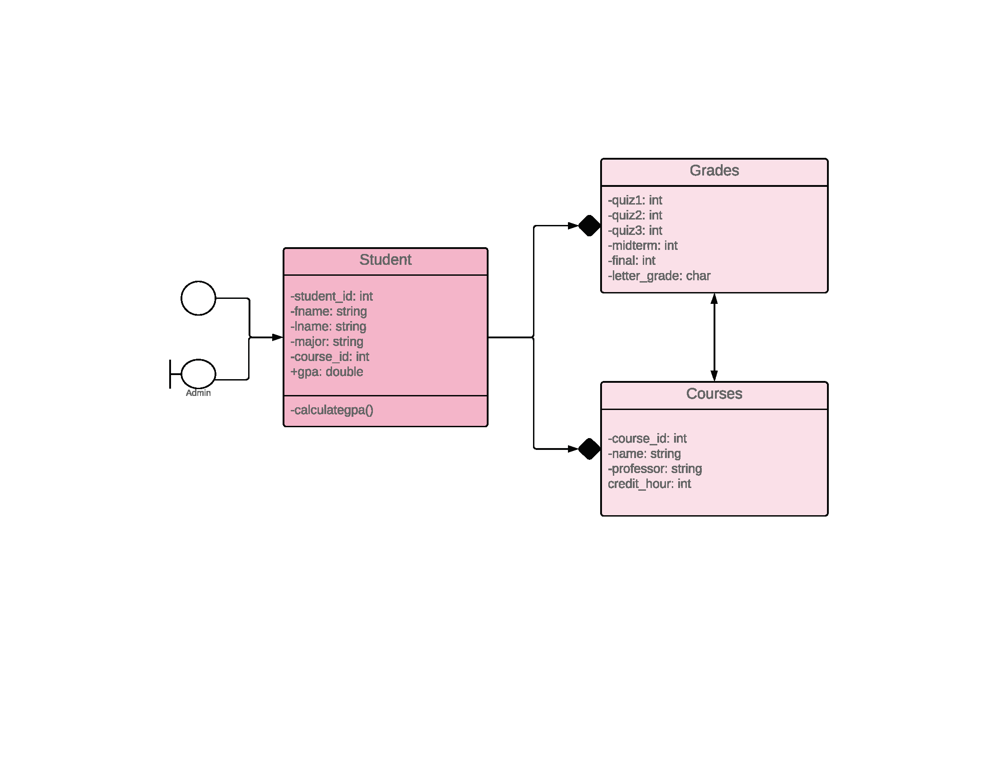

### Class Diagram & E/R Diagram



administrators



teacher_id INT(11)



fname VARCHAR(30)



lname VARCHAR(30)



courses



course_id INT(11)



name VARCHAR(30)



teacher_id INT(11)



grades

student_id INT(11)

course_id INT(11)



quiz1 INT(11)



quiz2 INT(11)



quiz3 INT(11)



midterm INT(11)



final INT(11)



students



student_id INT(11)



fname VARCHAR(30)



lname VARCHAR(30)



major VARCHAR(30)



course_id INT(11)

## Appendix F: CRC Cards

|  |
| --- |
| Class: Student |
| 1. Login to student view page. 2. Search for courses during current semester. 3. Search current grades. 4. View current grades 5. Show current grades. 6. Search for course instructor. |
| Subclasses:   * Login Subclass |

|  |
| --- |
| Class: Grades |
| 1. Display current grades 2. Calculate and report GPA to Student |
| Subclasses:   * GPA Subclass |

|  |
| --- |
| Class: Administrator |
| 1. Login to Administrator view page 2. Input Grades 3. Query Grades 4. Input Students 5. Query Students 6. Input Courses 7. Query Courses |
| Subclasses:   * Login Subclass * Grades * Courses * Students |

|  |
| --- |
| Class: Courses |
| 1. Display current courses |
| Subclasses:   * N/A |

## appendix G: Login Page

### Login page screenshot

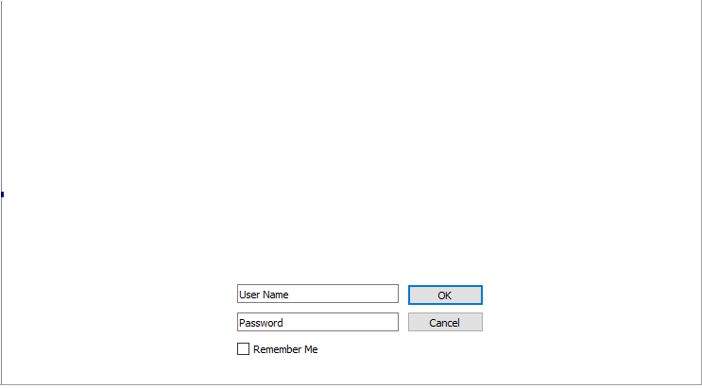

### Login Page Code

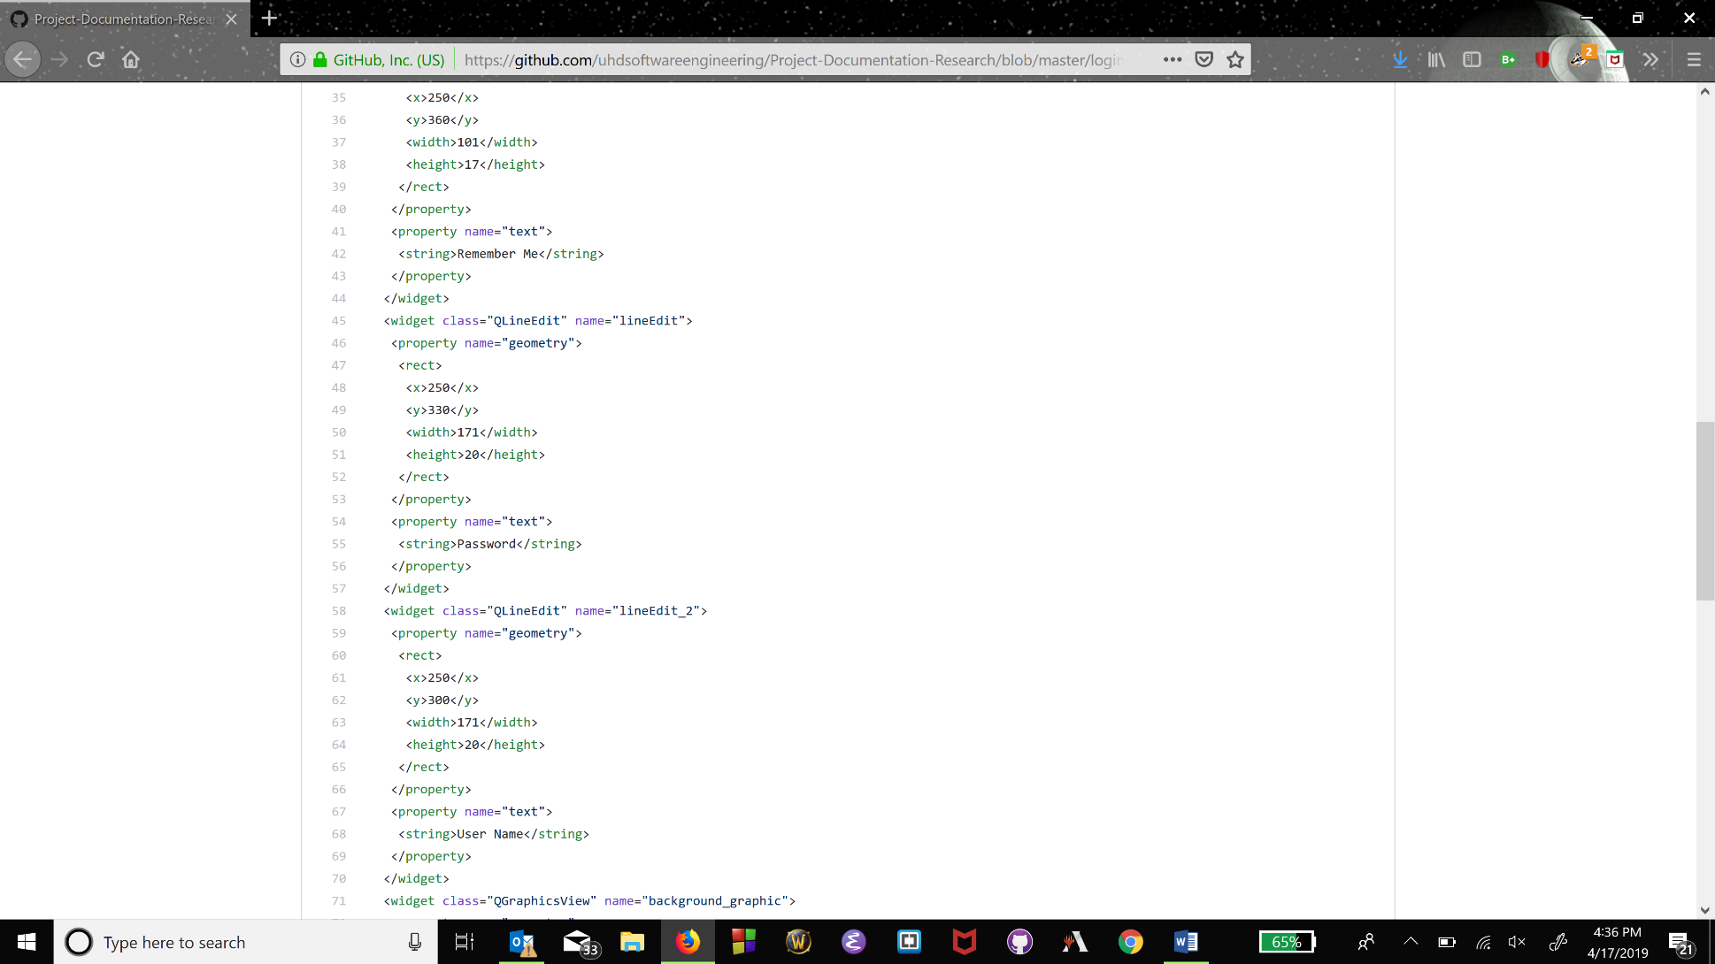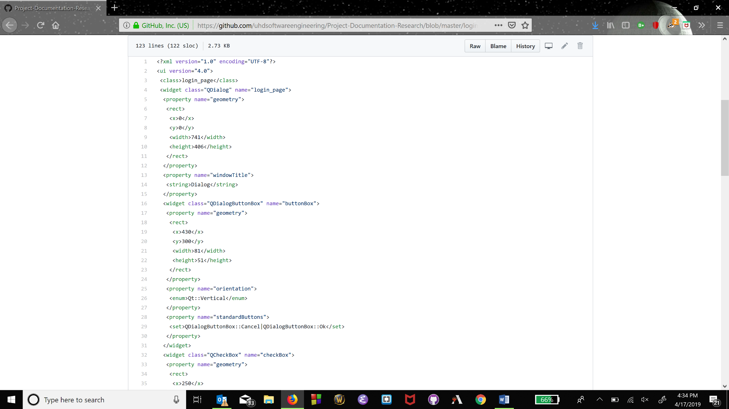

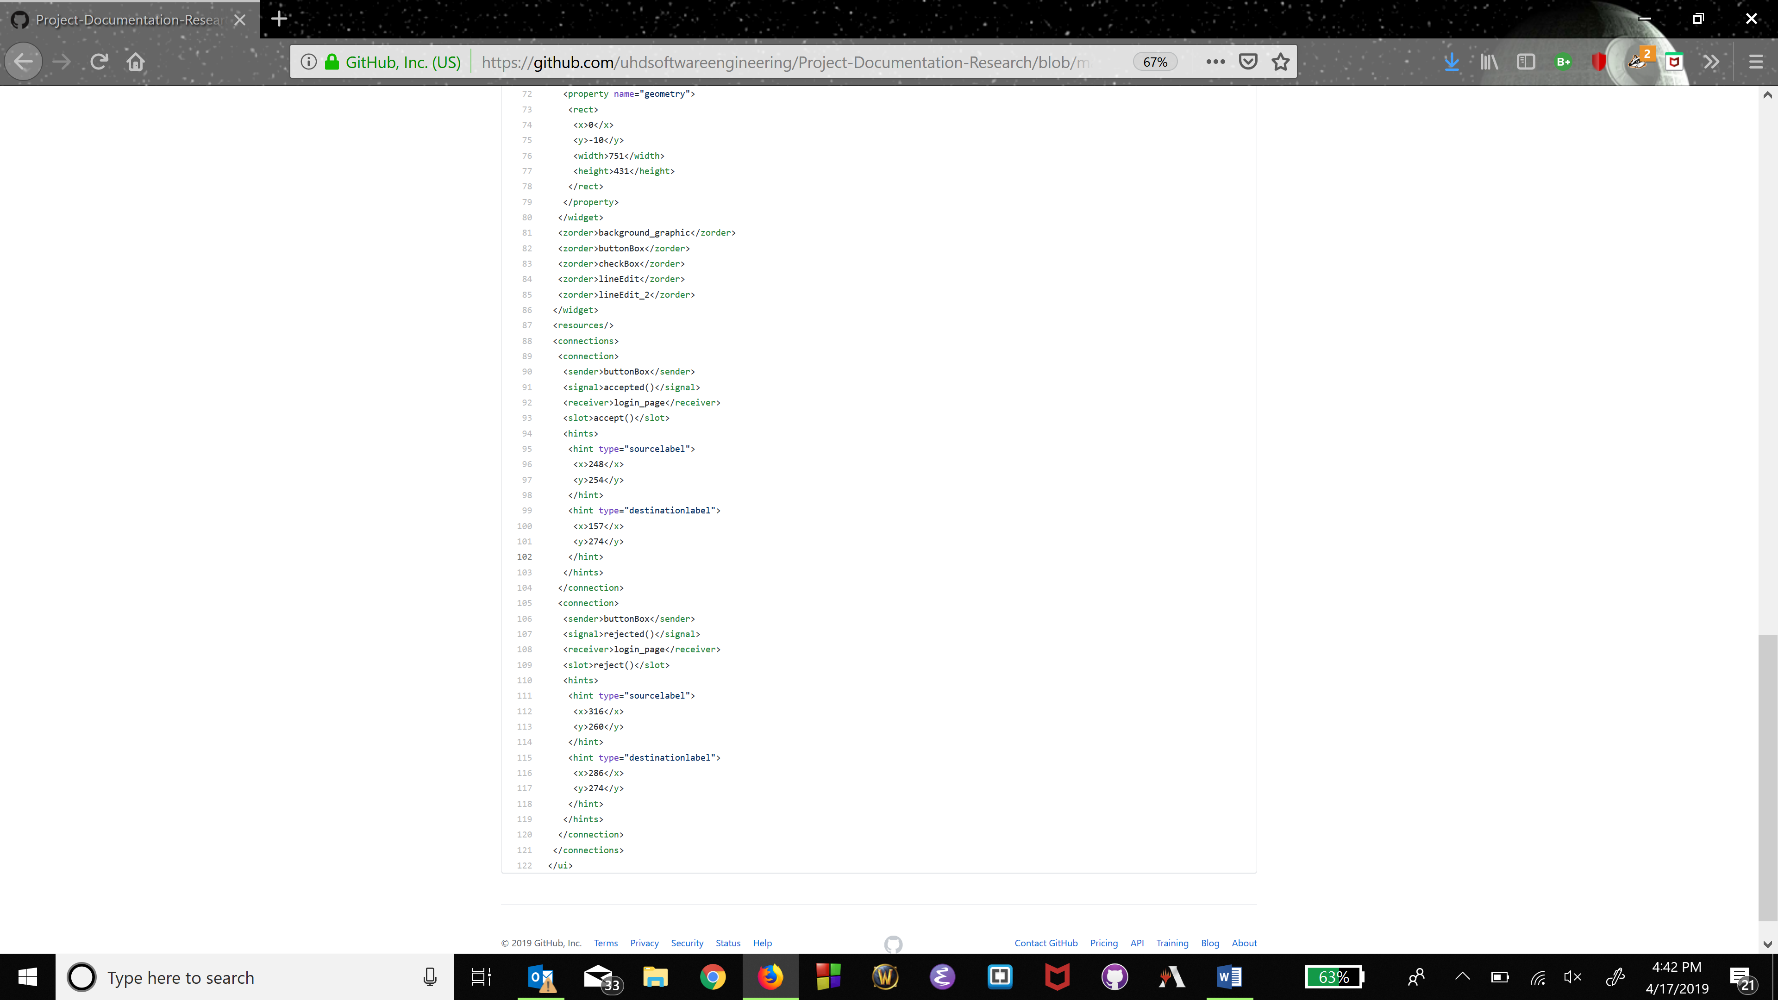

## appendix H: Main Window Code

### Version 1.0 Code

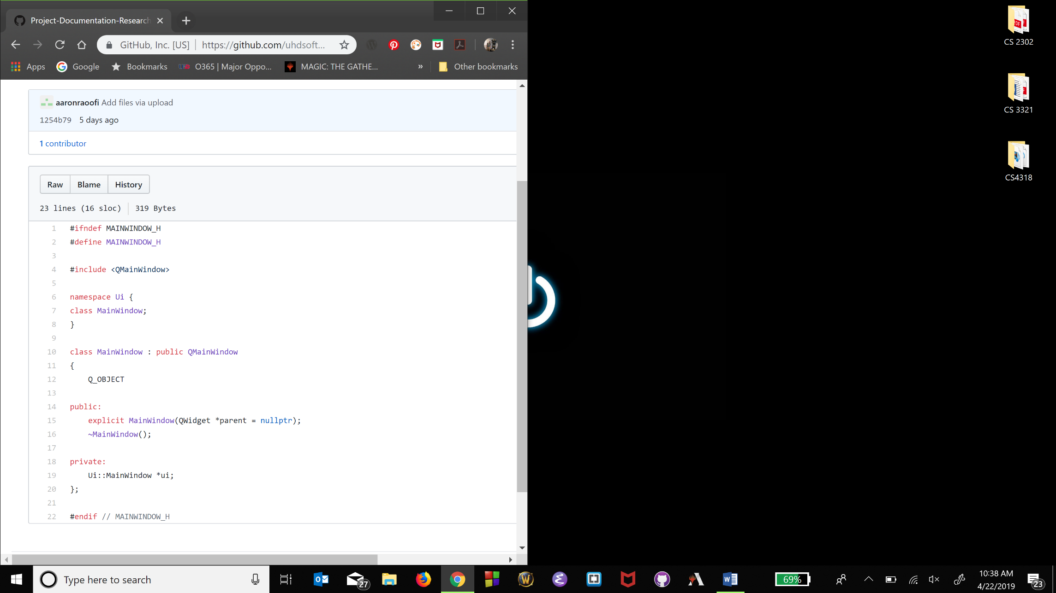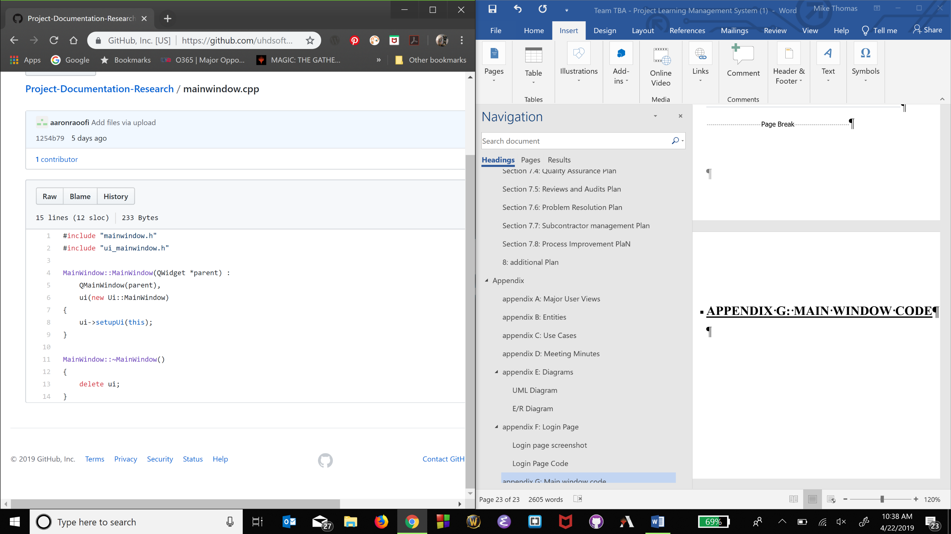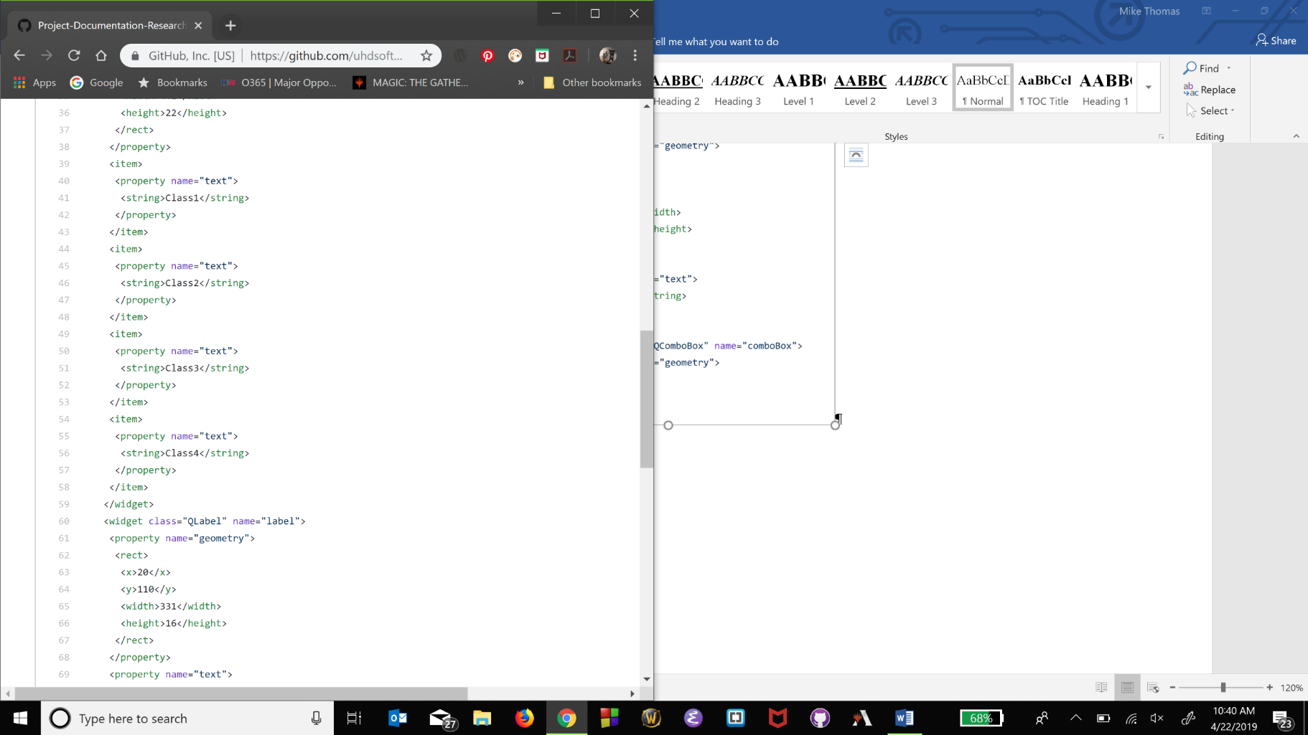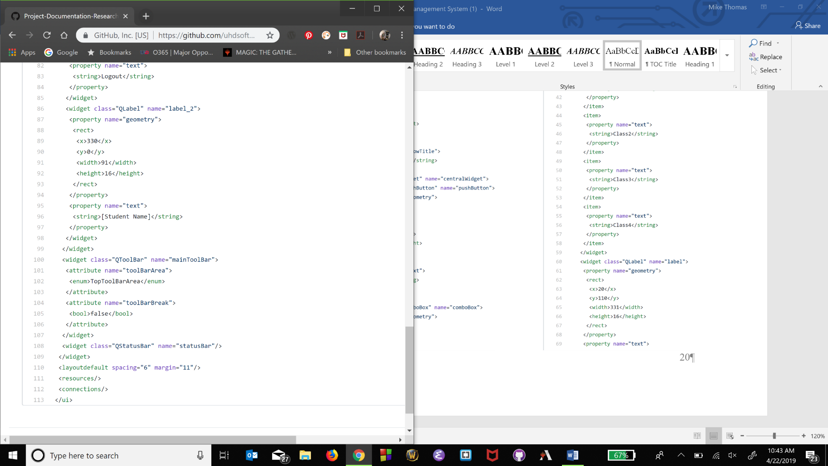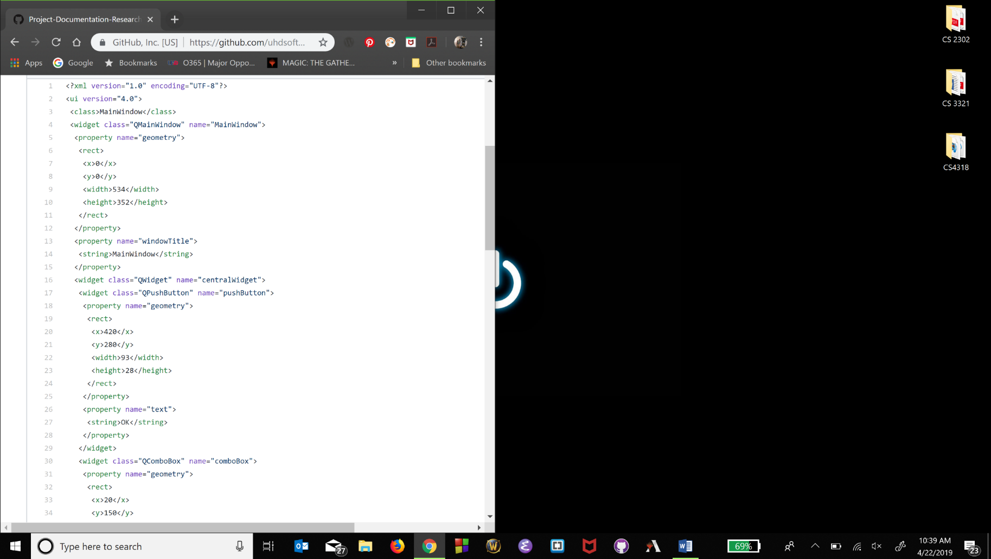

## appendix I: Student Page

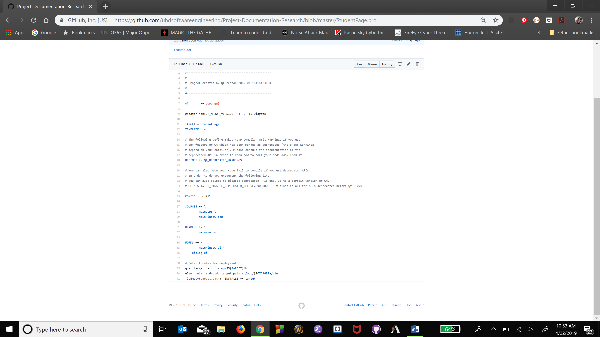

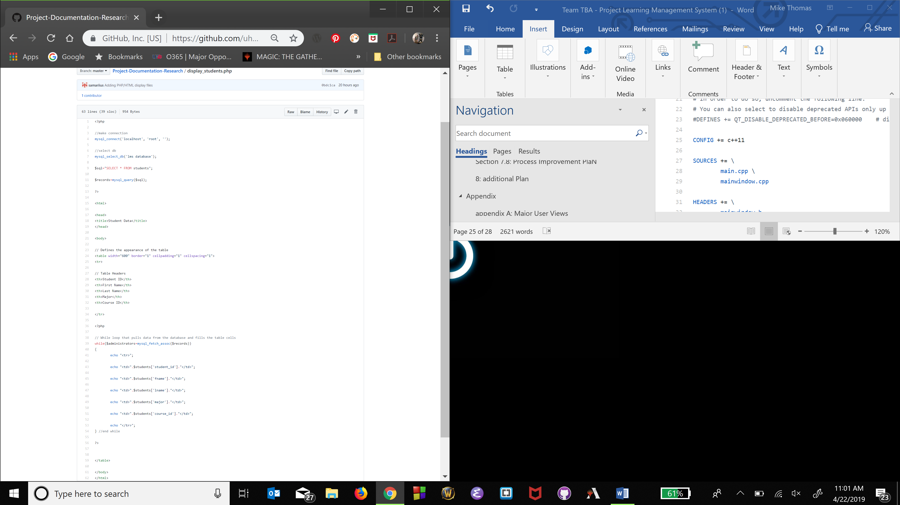

## appendix J: Administrator Page

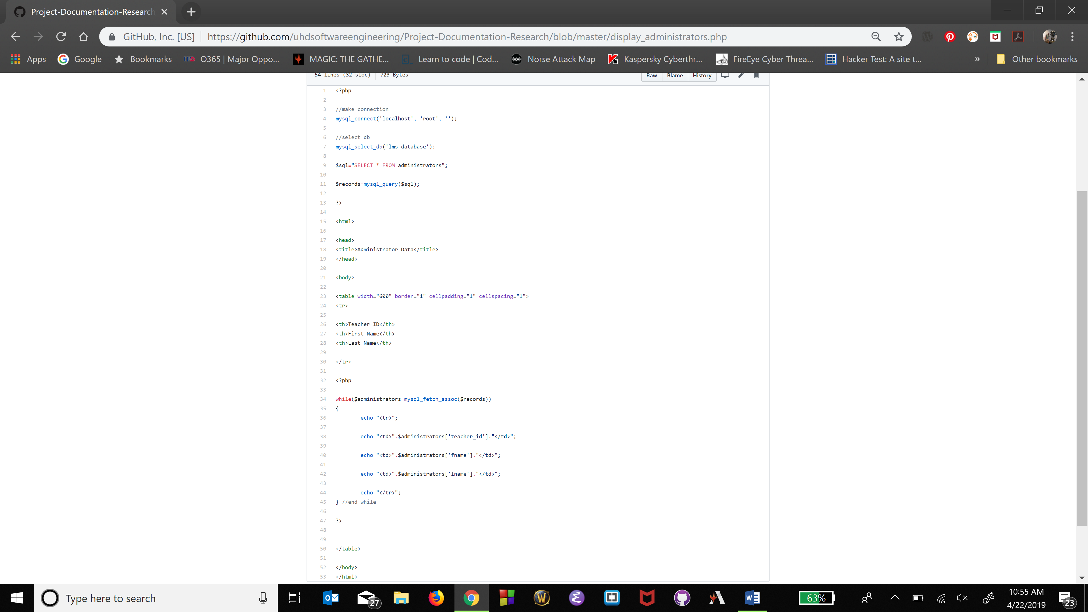

## appendix K: Courses Page

